**Classroom Activity: Send get, post, put and delete HTTP Request Using ThunderCloud.**

**You can test the routes using a tool like Postman or ThunderCloud:**

* **GET**: Retrieve all restaurants

GET

http://localhost:3000/restaurants

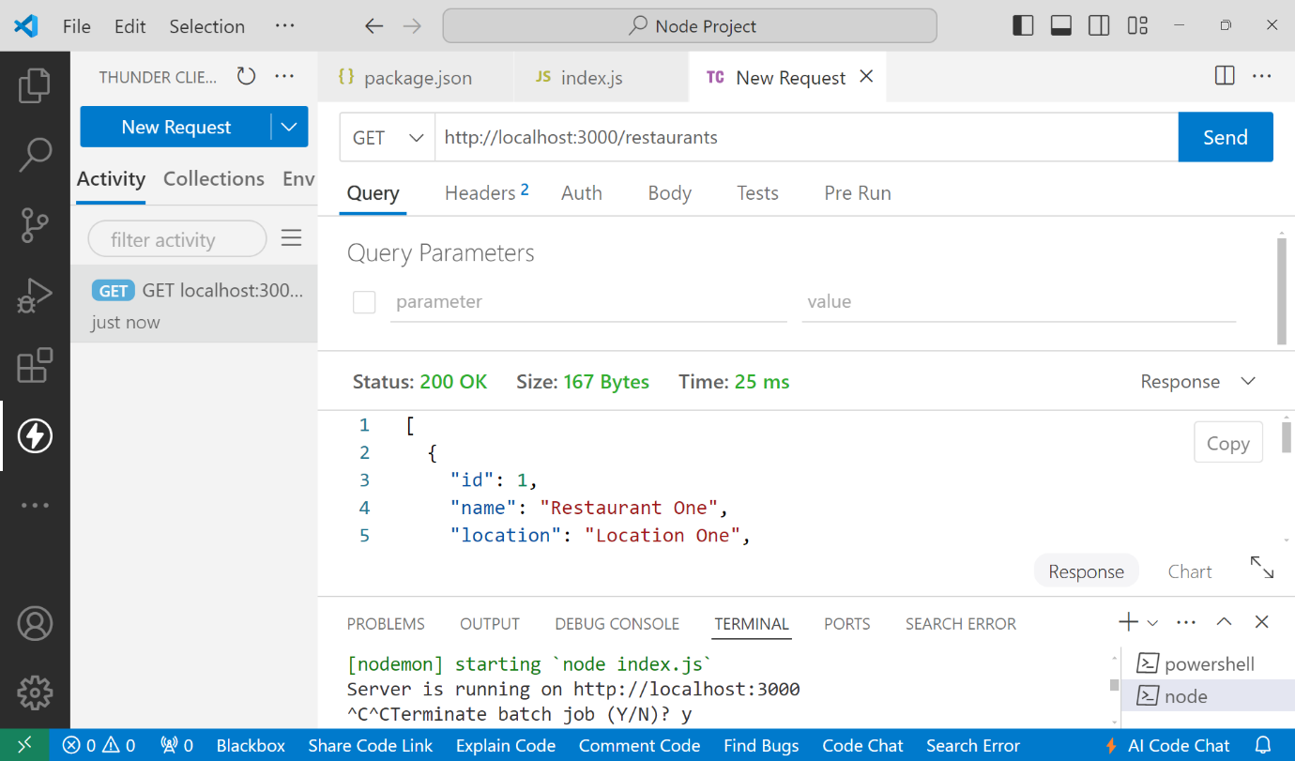

* **POST**: Add a new restaurant

POST

http://localhost:3000/restaurants

Content-Type: application/json

{

"name": "Restaurant Three",

"location": "Location Three",

"cuisine": "Cuisine Three"

}

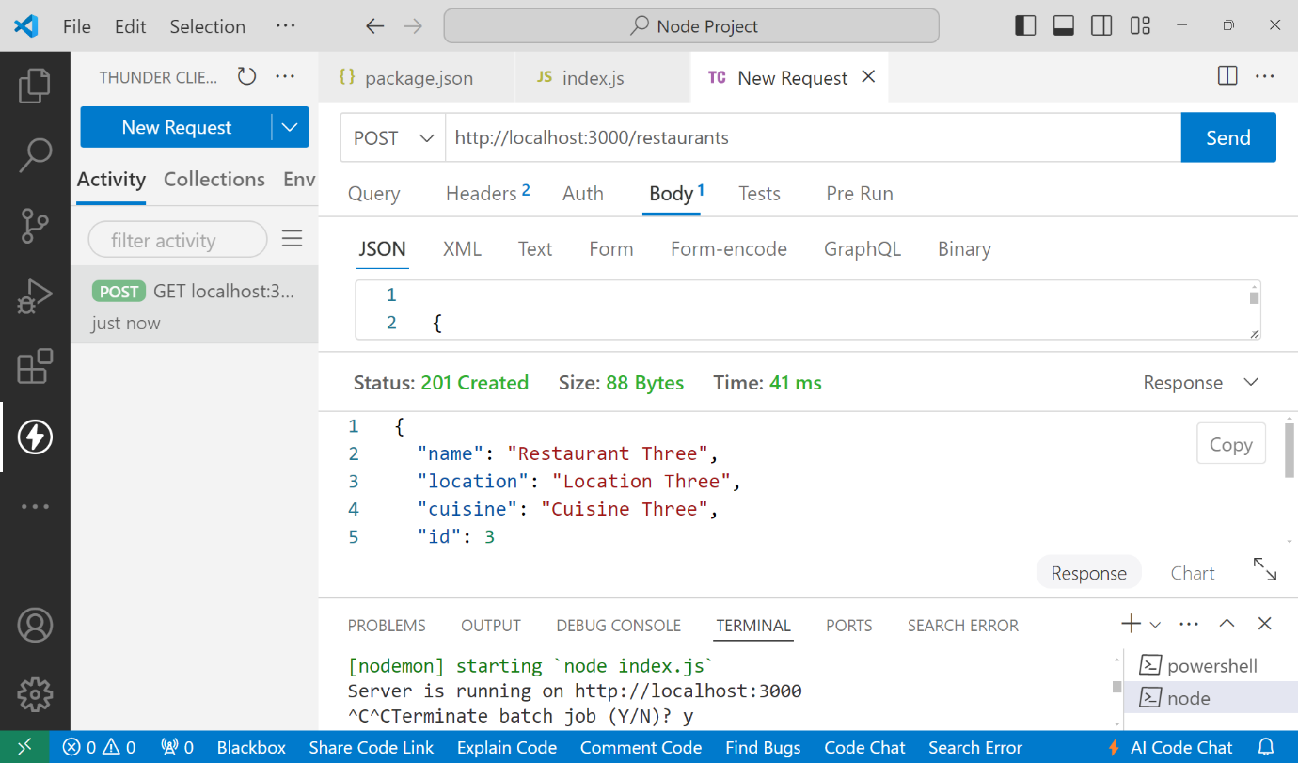

* **PUT**: Update an existing restaurant by ID

PUT http://localhost:3000/restaurants/1

Content-Type: application/json

{

"name": "Updated Restaurant One",

"location": "Updated Location One",

"cuisine": "Updated Cuisine One"

}

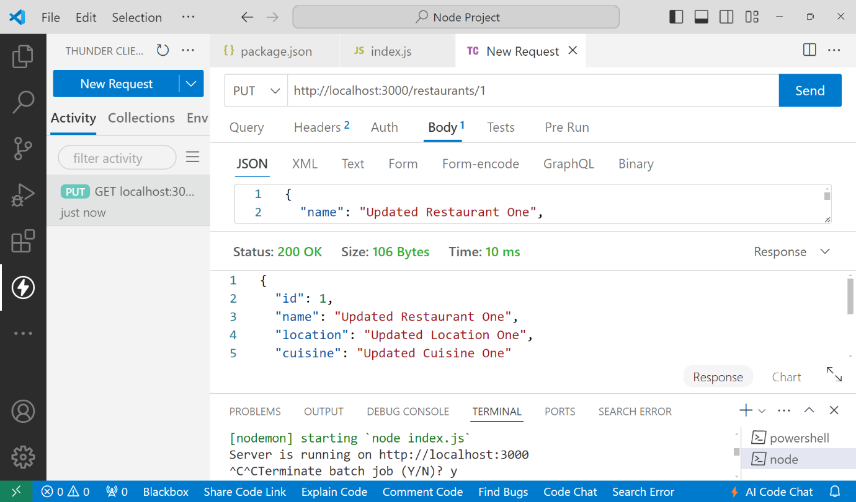

* **DELETE**: Delete a restaurant by ID

DELETE

http://localhost:3000/restaurants/1

